MEDIA RELEASE FROM GO LBG
GO finds its “forever home” on the Bridge
Guernsey-based social enterprise GO, short for GIVING OPPORTUNITIES, which primarily focuses on providing training and support to individuals in the community, has secured modern premises until at least the end of the decade.
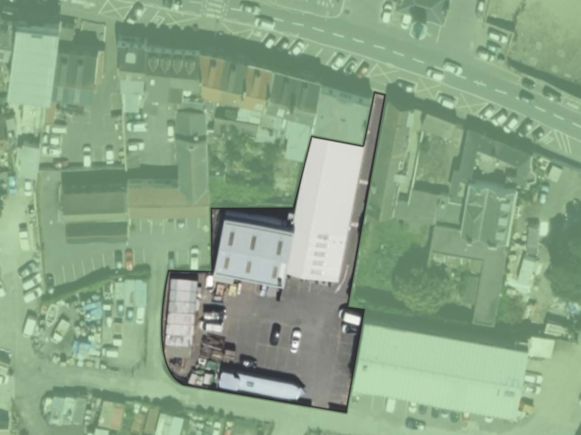
The organisation will move from its current location at Northside to the Southside on the Bridge in St Sampson's. The new location will be opposite the Weighbridge Clocktower, behind the Bathroom Emporium and is currently occupied by Bonsai interior designers. The aim is to complete the transition by the end of December, opening in January.
"We are delighted to have secured these modern premises, which will allow us to train more people and equip them with the skills they need to succeed," said Chris Murphy, GO's General Manager. "We will continue improving our product range to serve our loyal client base. Staying on the Bridge is great news, offering excellent parking facilities for customers and easy public transport links for our trainees and staff."
The new facility, which offers 6000 square feet of space, will enable the social enterprise to increase the number of trainees who benefit from GO's training programs, allowing them to acquire the skills needed to apply for the many jobs on offer on the island. Individual trainees come from diverse backgrounds, including those with learning disabilities, mental health issues, and conditions such as autism. GO also assists ex-offenders and those who are educationally disadvantaged.
Existing training areas for activities such as Retail, IT, Bicycle and Furniture refurbishment will be recreated on the new site. GO will transfer its training areas and retail stock to the new site in December, and full trading will commence in January 2024.
Having recycled over 500 tonnes of materials that would have otherwise ended up in a landfill, GO is committed to continuing and expanding this sustainable activity.
"We are delighted to have secured an ideal home for GO well into the medium term," said Paul Meader, Chairman of GO's Board of Directors. "Our charity will now be able to continue to increase the number of people we help back into the world of work while continuing to meet the needs of our loyal customers through our recycling and upcycling activities."
For further information, contact Malcolm Hart, GO Director, on 07781 120 190
ENDS
Chris Murphy, General Manager
Chris has lived in Guernsey for 28 years. Brighton-born and raised, he has a varied employment background, including being a professional footballer and plasterer and working in the hospitality industry.
More recently, he has worked for the Guernsey Prison and Probation Services, where he started the Community Service Scheme (run out of the Probation Service) when it was introduced in the Bailiwick in 2007. Chris says, "I have been employed at GO for nearly three years. My passion is working with people and trying to help people progress on their own individual journeys"

Paul Meader, Chairman, Board of Directors
Paul spent his formative years in Guernsey and has been working in financial services for 35 years on the island, as well as in London and Dublin.
He is a seasoned company director with extensive experience and has been actively involved with several third-sector organisations for the past 25 years.
The majority of his work with these organisations has been focused on providing access and opportunities to everyone in the community.

